1. **INTRODUCTION** 
   1. Overview

A brief description about your project

* 1. Purpose

The use of this project. What can be achieved using this.

**2 Problem Definition & Design Thinking**

2.1 Empathy Map

Paste the empathy map screenshot

2.2 Ideation & Brainstorming Map

Paste the Ideation & brainstorming map screenshot

1. **RESULT**

Final findings (Output) of the project along with screenshots.

1. **ADVANTAGES & DISADVANTAGES**

List of advantages and disadvantages of the proposed solution

1. **APPLICATIONS**

The areas where this solution can be applied

1. **CONCLUSION**

Conclusion summarizing the entire work and findings.

1. **FUTURE SCOPE**

Enhancements that can be made in the future.

1. **APPENDIX**

# IDENTIFYING PATTERNS AND TRENDS IN CAMPUS PLACEMENT DATA USING MACHINE LEARNING

**1 INTRODUCTION**

**1.1 Overview**

* + - Campus recruitment is a strategy for sourcing, engaging and hiring young talent for internship and entry-level positions.
    - College recruiting is typically a tactic for medium- to large-sized companies with high-volume recruiting needs, but can range from small efforts (like working with university career centers to source potential candidates) to large-scale operations (like visiting a wide array of colleges and attending recruiting events throughout the spring and fall semester).
    - Campus recruitment often involves working with university career services centers and attending career fairs to meet in-person with college students and recent graduates.
    - Our solution revolves around the placement season of a Business School in India.
    - Where it has various factors on candidates getting hired such as work experience, exam percentage etc., Finally it contains the status of recruitment and remunerate.

**1.2 Purpose**

* + - * We will be using algorithms such as KNN, SVM and ANN.
      * We will train and test the data with these algorithms.
      * From this the best model is selected and saved in.pkl format.

We will be doing flask integration and IBM deployment.

Data collection

Collect the dataset or create the dataset

Visualizing and analyzing data

Univariate analysis

Bivariate analysis

Multivariate analysis

Descriptive analysis

Data pre-processing

Checking for null values

Handling outlier

Handling categorical data

Splitting data into train and test

* Model building
  + - * + Import the model building libraries
        + Initializing the model
        + Training and testing the model
        + Evaluating performance of model
        + Save the model
* Application Building
  + - * + Create an HTML file
        + Build python code

**2 Problem Definition & Design Thinking**

* + - * **Design thinking is a non-linear, iterative process that teams use to understand users, challenge assumptions, redefine problems and create innovative**
      * **Empathize, Define, Ideate, Prototype and Test.**
      * **Retaining valuable employees and predicting the impact of new policies to**
      * **creating new valuable products and services.**

**2.1 Empathy Map**

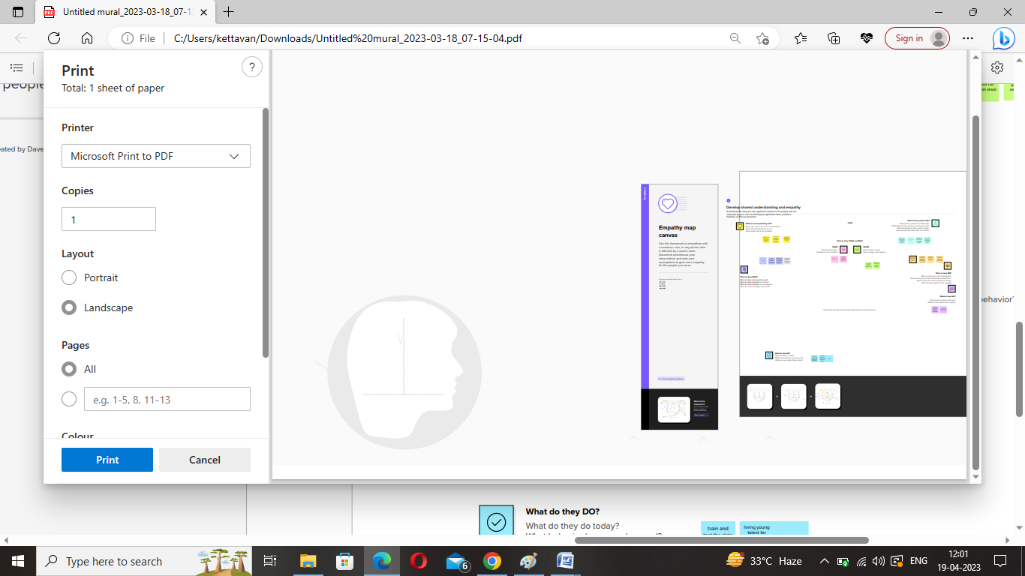

**2.2 Ideation & Brainstorming Map**

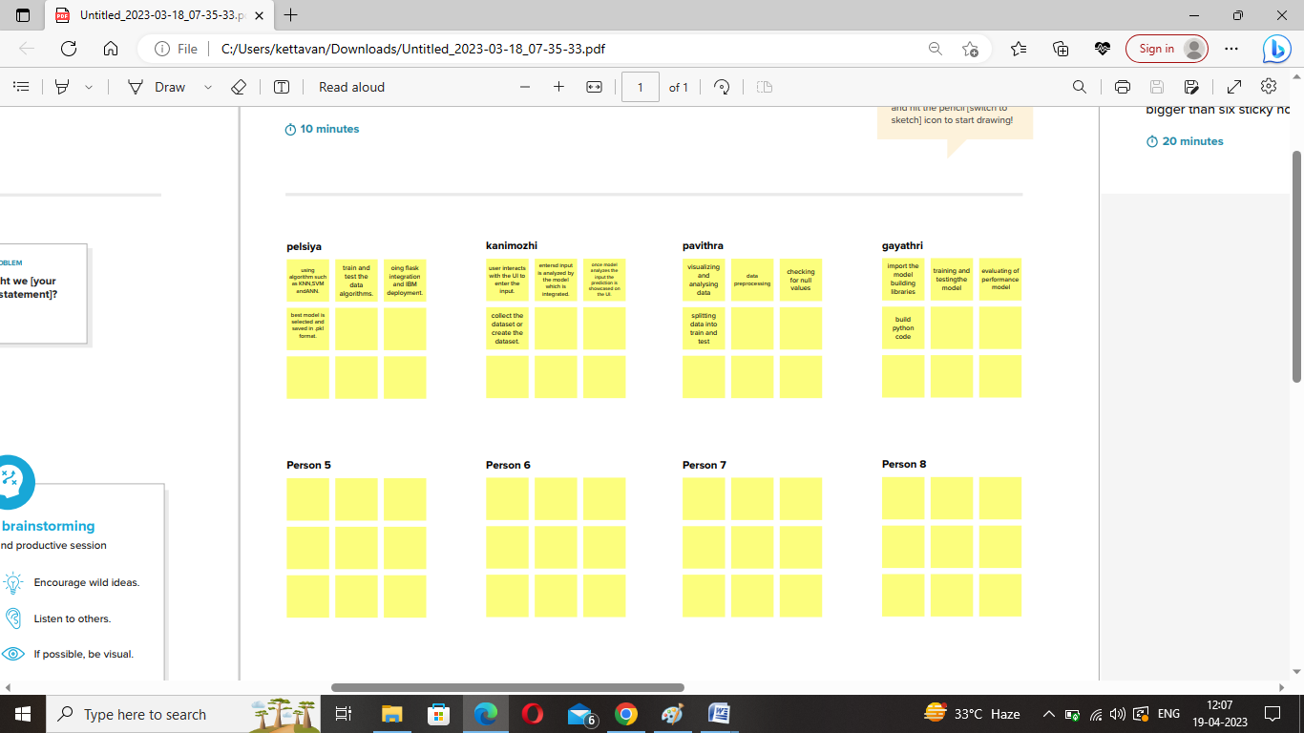

# 3 RESULT

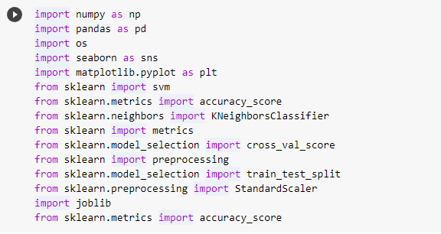

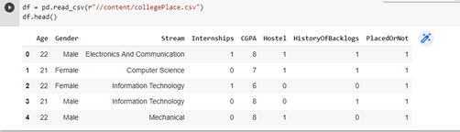

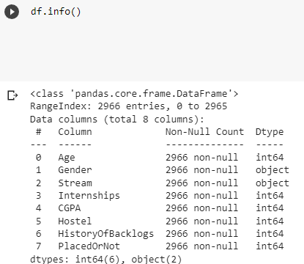

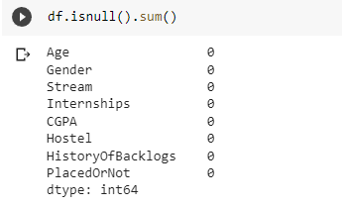

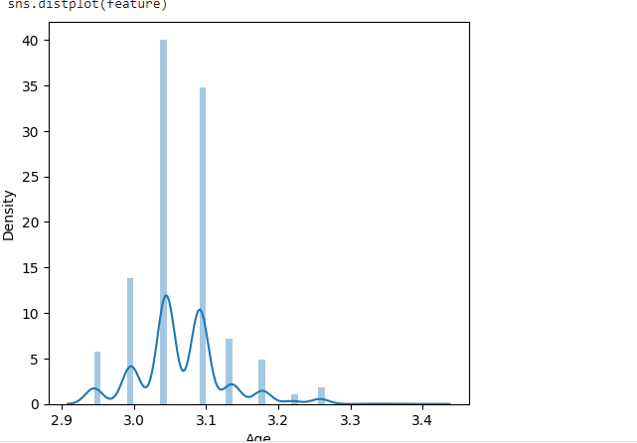

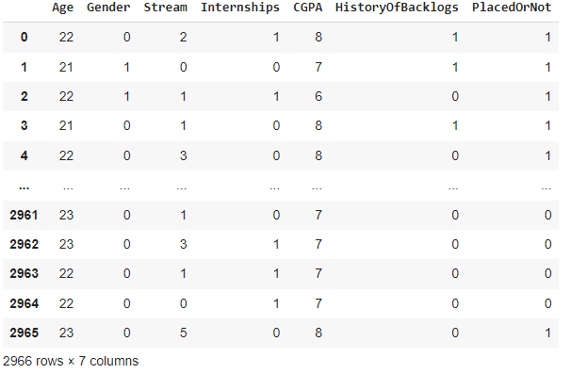

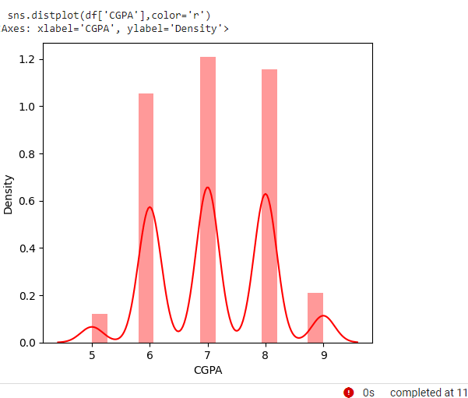

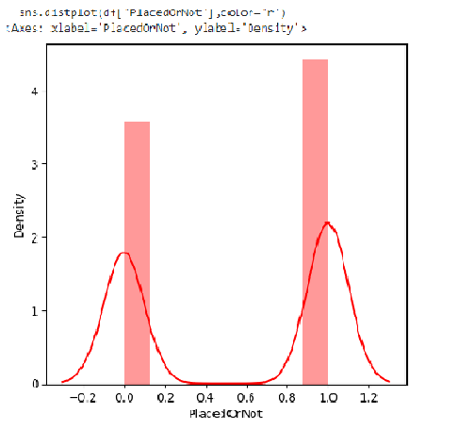

# 4 ADVANTAGES & DISADVANTAGES

# 4.1 ADVANTAGES

* + It's important to note that all these studies are quite old now and you might find more recent studies and new techniques which can be useful for your project.
  + In general, these studies found that machine learning techniques were effective at identifying patterns and trends in campus placement data, and could be used to predict student placement outcomes with high accuracy.
    - Trend analysis allows you to predict what's going to happen, based on what's already happened.
    - It provides businesses with information regarding marketing and sales performance, product development, spending, and more.
    - Enabling businesses to make data-driven decisions with regard to future events.
    - The trends across your customers and sales will help you decide how to manage customer service and how efficient your salespeople are.

**4.2 DISADVANTAGES**

* Distortions: Historical data may not be an accurate representation of a trend.
* Determining cause: It is very difficult to determine the cause of a trend.
* Large sample sizes: For accurately and reliably analyzing a trend, large amount of data needs to be collected.
* Errors.
* The planet can't take it anymore (no, seriously!).
* Fashion trends keep you trapped in a vicious (and costly) cycle.
* They don't allow you to find your own style.
* Find your own clothing style.
* Remove temptations.
* Find your tribe.

**5 APPLICATIONS**

* + - Trend analysis is a technique used to examine and predict movements of an item based on **current and historical data**.
    - You can use trend analysis **to improve your business using trend data to inform your decision-making**.
    - **Scalable and interactive data mining methods**.
    - Integration of data mining with database systems, data warehouse systems and web database systems.
    - Standardization of data mining query language.
    - Visual data mining.
    - Machine learning uses mathematics, statistics, and domain-specific knowledge and data to solve complex problems.
    - What is machine learning? Here is a very simple definition.
    - Machine learning is turning things (data) into numbers and **finding patterns** in those numbers.
    - For finding patterns, algorithms are used. An algorithm is a specific set of steps to perform a task.
    - An **“*algorithm*”** in machine learning is a procedure that is run on data to create a machine learning **“*model*”**.
      * A machine learning *algorithm* is written to derive the *model*. The *model* identifies the *patterns* in data that **fit** the *dataset*.
      * ***Fit*** is a synonym to **“find patterns in data”**.
      * A **“*model*”** in machine learning is the output of a machine learning algorithm run on data.
      * A model represents what was **learned** by a machine learning algorithm.
      * It is basically a mathematical function that can adapt to new data by tweaking its parameters.

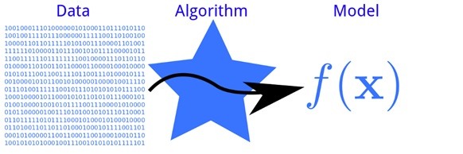

# 6 CONCLUSION

* **The entire study of trends relies on specific signals and confirmation. However, these are usually found in some degree and with consistency.**
* **Finally, consider including a conclusion at the end of the trend report summarizing the major findings of the report along with recommendations based on these findings.**

# 7 FUTURE SCOPE

# **Trend analysis is a technique used to examine and predict movements of an item based on current and historical data.**

# **You can use trend analysis to improve your business using trend data to inform your decision-making.**

# 8 APPENDIX

1. **Source Code**



